1. Write a function to calculate the total stock value for a given category:  
   (Stock value = ROUND(SUM(unit_price * units_in_stock)::DECIMAL, 2)  
   Return data type is DECIMAL(10,2)

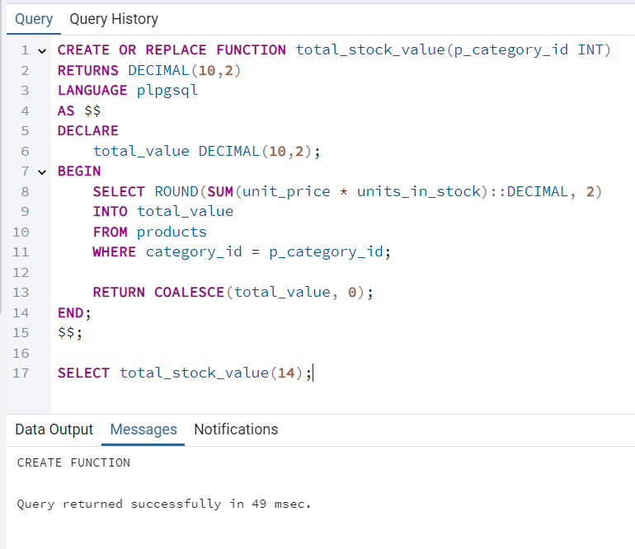

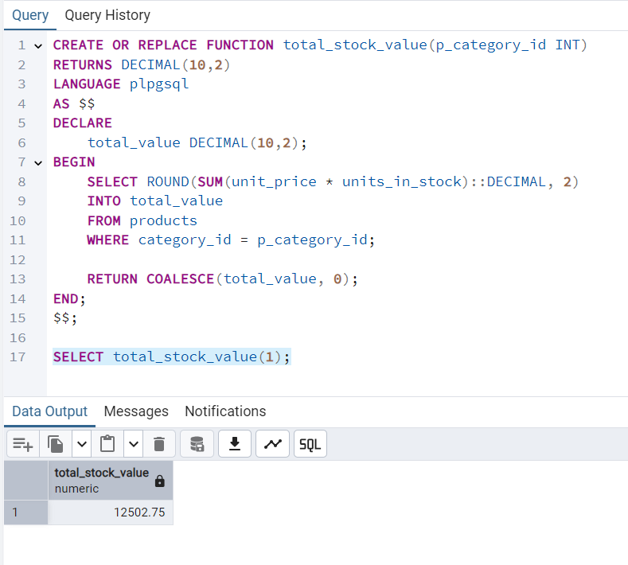

1. Try writing a cursor query which I executed in the training.

